1. Go to [www.nyiso.com](http://www.nyiso.com)
2. Navigate to Markets/Load Data

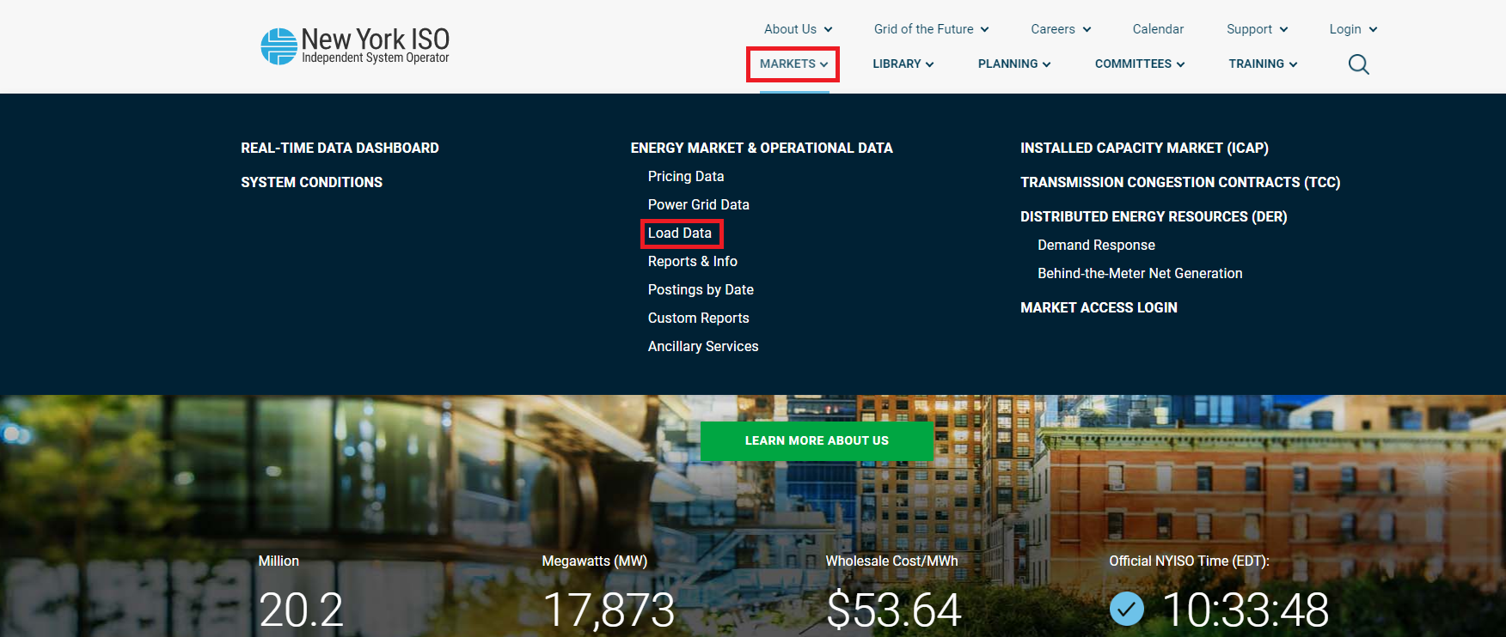

1. Click on Actual Load/Real-Time/Custom Report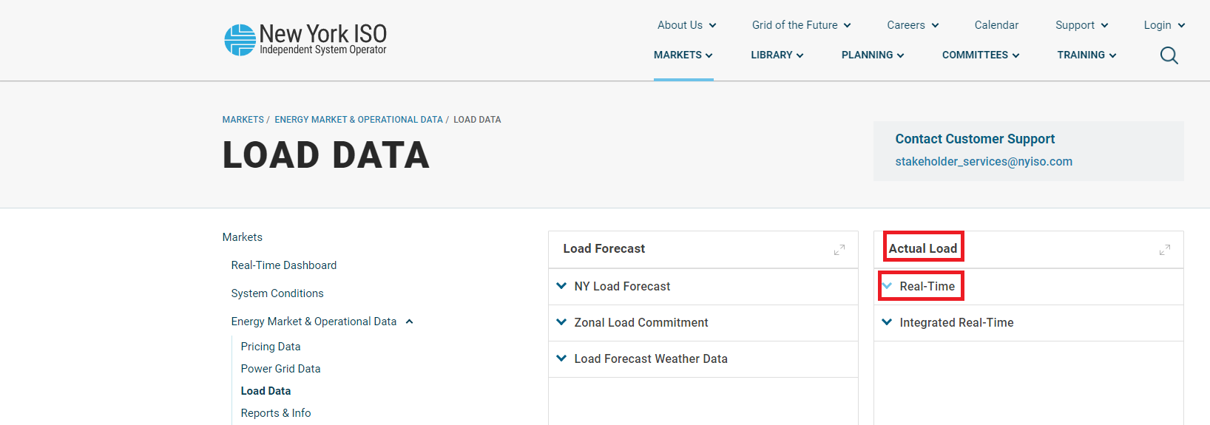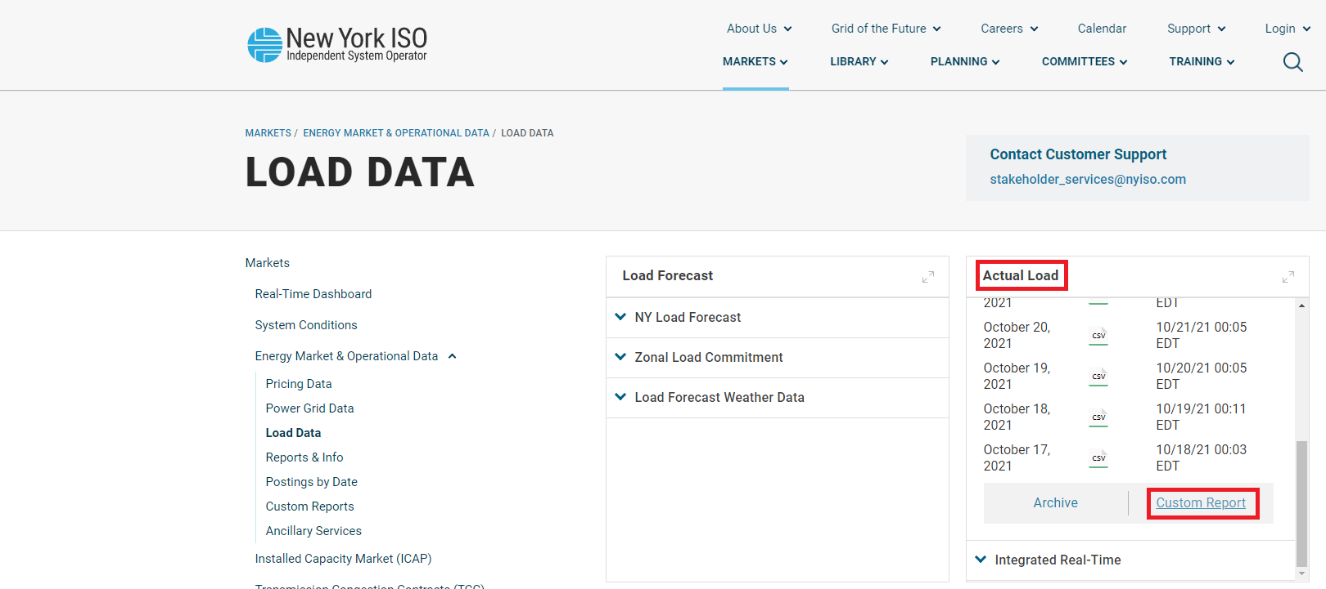
2. Choose the CAPITL zone and the time range 01/01/2018--12/31/2018, and click on GENERATE REPORT

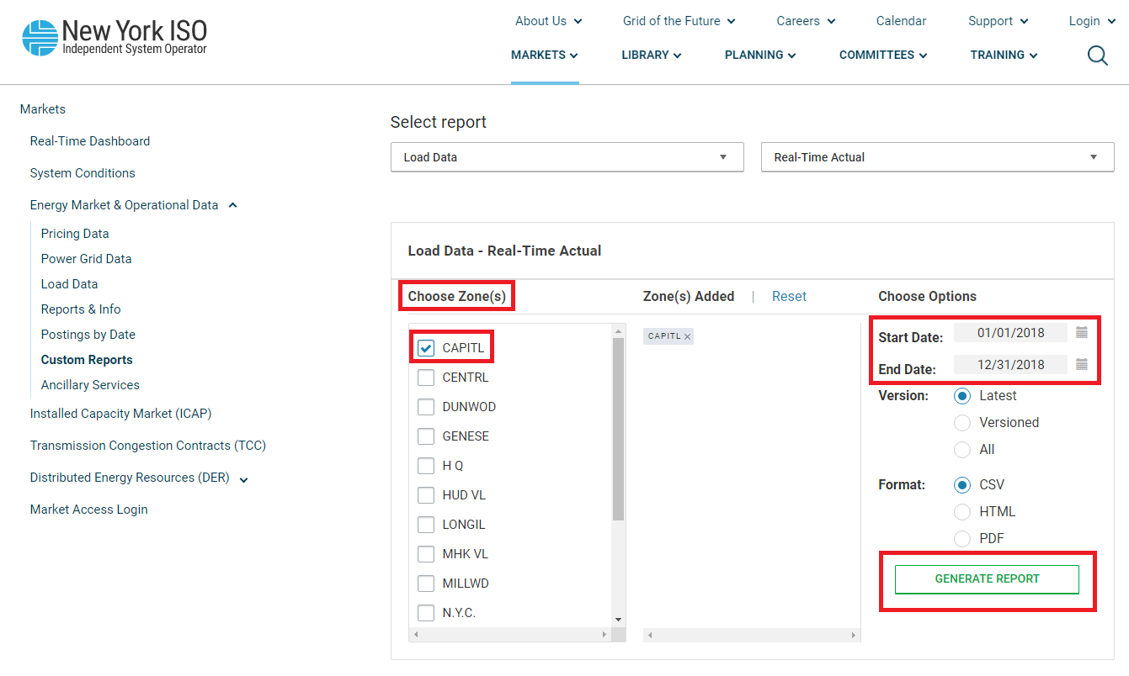

1. Repeat steps 4 and 5, but this time choose the time range 01/01/2019—12/31/2019

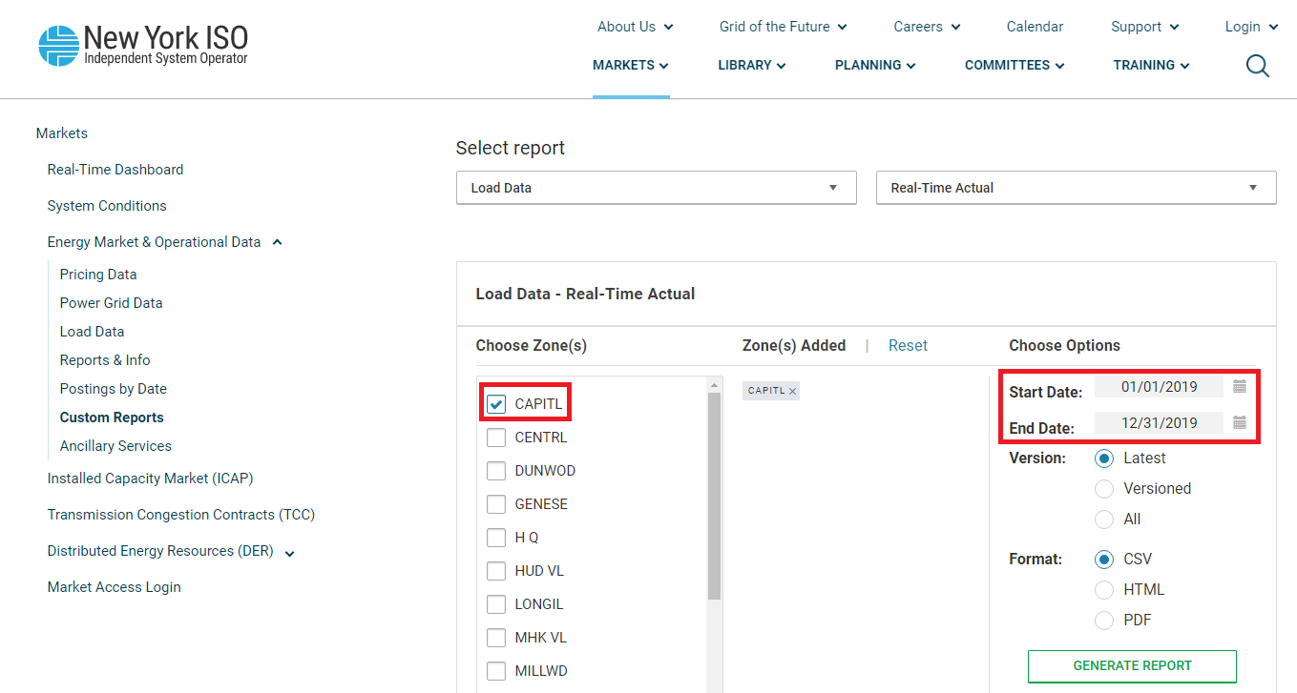

1. Rename the files to “load_NYC_2018” and “load_NYC_2019”